A Literature Review on Recommendation Systems

# Abstract -

*Recommendation system is a data filtering technique. They are used to provide suggestions to the users according to their interest and need. It is a very popular technique in recent years and used by many e- commercial websites and other platforms to recommend news, books, movies, shopping items, novels, music and much more that is why recommendation system has become a hot topic. Recommendation systems are the subset of data filtering systems. The different types of recommendation systems are used in different platforms and have become an important part of various applications. It is a decision making process that will help the users to buy items in which they are interested.*

*Recommendation systems are very useful and effective technique of filtering the data. This paper is a review of recommendation systems that will describe recommendation system, how it works and helps in different platforms, and the different types of it with their merits and limitations.*

1. **INTRODUCTION -**

According to Anna Gatzioura and Miquel Snchez [1], the aim of recommendation system is to provide effective and meaningful content (item) to the user which is active on the platform. Recommendation systems have become very popular in latest years. The first paper on collaborative filtering is appears in mid-1990s after that recommendation systems become an active area of research. Recommendation system is a technology which is used for filter and retrieval the data. With the help of these systems the sales of e-commercial websites and other platforms is also enhance. These systems are basically a software tool that provides the services and items to user, in which they are interested and help the users to find the item which they like. It is now a general term for providing the services to user according to him/her taste. According to K. Shah, A.k Salunke, S. Dongare, and K. Antala [2], recommendation systems are a machine learning technology that comes under unsupervised learning machine learning models in which data is not labelled, as mention in following figure-

Fig.1. Recommendation Systems in Machine Learning

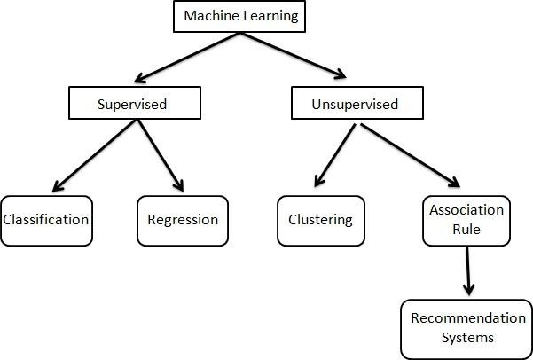

In the methods of unsupervised machine learning, the task of machine or model is to group the uncategorised data, according to similarities, patterns and differences without given any kind of training to the machine. Recommendation system is a part of unsupervised machine learning in which the data is not labelled; so the hidden and cluster information is revealed by unsupervised learning methods. Many websites are using recommendation systems to give a better experience to the users. The best examples of recommender systems are given by J. Ben Schafer, Joseph Konstan, John [18], that you have seen the suggestions on Amazon like “Customer who bought”, “Amazon.com Delivers”, “Book Matchers”, on Moviefinder.com like “We Predict”, “Match Maker”, on Reel.com, eBay and more. They summarized the technologies, applications and the things by which the user is able to find the suggestions and how the user find these recommendations. Recommendation systems are very useful techniques to filtering data because it helps to know about the user more. Every platform has different kinds of recommend system, according to the platform.

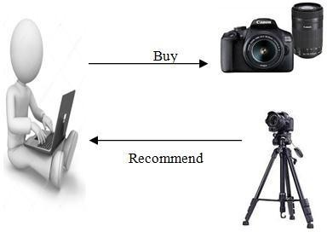

Fig.2. Recommendation System

As show in above figure, a user bought a camera so recommender system gave him/her suggestion to buy a tripod. The products have been shows at the top of the screen, on the basis of past behaviour and user’s taste. Basically this is the working of recommendation system in these platforms. These recommendation systems are using for filter the data and gave the user a better experience and they are become a common part of everyone’s life because providing recommendations to anyone is a very difficult task but it is done by these systems, that is why these systems become more popular in area of research.

1. **TYPES OF RECOMMENDATION SYSTEMS -**

Recommendation systems are of two types, Personalized and non-personalized. Personalized recommendation systems are those in which the group of different users is receive different suggestions where as in non- personalized recommender systems all users get same suggestions [2]. According to J. Ben Schafer, Joseph Konstan, John [18], Non-personalized recommendation systems are automatic because in these systems recommendations are not based on customers so these systems doesn’t recognized the users from one session to another and these systems requires a physical storage. Recommendation systems are grouped into these categories- Content Based Filtering, Collaborative Filtering and Hybrid Systems. All the techniques are using in different platforms and they have their advantages and disadvantages. The paper will describe all the techniques with their advantages and limitations in the following sections.

**Content Based Filtering:**

According to Po-Wah Yau and Allan Tomlinson [7], Firstly the quality of item is analyzed and after that the properties of product are matched, for this the present database is used. In content based filtering techniques, the items are described with the help of keywords. Content based filtering algorithms predict the item that the user liked in the past and according to the rating of user the items are recommended. In content based filtering the quality of the product or services are utilized for recommendation. For an active user content based filtering techniques provide transparency. In content based filtering the system compare the profile of the user with the content (item) and then find similar item and suggest to the user.

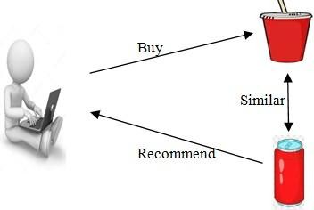

Fig.3. Content Based Filtering

The merits of using content based filtering are that these techniques are less cumbersome because they provide user independence with the help of rating used by the user. For a new user content based filtering techniques are good where as the limitations of content based filtering is that sometime it can be suggest same type of items this is called a over specialization problem and in case of a user does not give rating or feedback then it is difficult to suggest any item or suggestion may be wrong.

**Collaborative Filtering:**

In 1992, “Collaborative Filtering” was invented by Goldberg el al. [4], they conclude that for humans the process of information filtering has become very effective. The meaning of word collaboration is that people collaborate to help each other to complete a task. In collaborative filtering techniques, data and information is collected by the system (database) from different users and then based on likes and dislikes of the user the results are compared and similar item will be suggested. In the methods of collaborative filtering the interest of one person is compared with the other user’s interest and then similar items are suggested to the user.

According to G. Gupta and R. Katarya [3], Collaborative Filtering is a technique in recommender systems in which the recommendations are dependent on the user’s neighbors and this technique use the concept of matrix factorization in which a matrix contain the users, items and the rating provide by the item with the different kind of users. These techniques are used in many kinds of e-commercial platforms and provide a better experience to suggest contents (items) than other techniques.

The following diagram easily defines the working of collaborative filtering techniques-

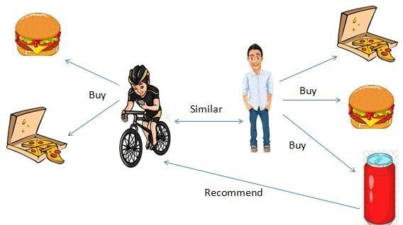

Fig.4. Collaborative Filtering

**Hybrid Systems**:

In content based filtering technique, the algorithm is based on contents of items and collaborative filtering technique algorithm combines the relationship between user and item. Both of the approaches of recommendation system are suffers from some limitations, this is a big issue to predict better recommendations to the user. Hybrid systems are introduced to overcome the main limitations of these both techniques. These systems are make with the combo of content based and collaborative filtering techniques and have advantages of both the techniques. With the use of hybrid systems the quality of recommendations are improved.

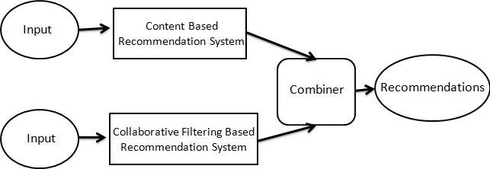

Fig.5. Hybrid Recommendation System

According to International Conference on Intelligent Human-Machine Systems and Cybernetics [14], Hybrid recommendation systems uses previous data of a user to find his/her interest and then they target the set of adjacent user which is similar with that user and according to adjacent user recommend things to the user. Hybrid systems offer the items that share the common things that a user rated highly (Content based filtering) and makes suggestions by compare the interest of similar user (Collaborative filtering). The best example of hybrid recommendation system is Netflix [15]. The hybrid systems can be consist of following types-

* 1. Integrate the content based filtering methods into collaborative filtering methods or vice versa.
  2. Implement content based methods separately and then merge their predictions.
  3. Merge both content based filtering and collaborative filtering methods and develop a general model.

1. **RECOMMENDATION SYSTEM- A LITERATURE REVIEW-**

**TABLE.1. A REVIEW OF WORK DONE BY VARIOUS AUTHORS**

|  |  |  |  |  |  |  |  |
| --- | --- | --- | --- | --- | --- | --- | --- |
| S. No. | Title of the Paper | | Key Points | | Conclusion | | Reference |
| 1. | A Case-Based Recommendation Approach for Market Basket Data. | | CF, CB, AR  Rule), CBR Reasoning) | (Association (Case-Based | After compared the performance of developed RS conclude that CBR is the good method in case of  transactions. | | [1] |
| 2. | Recommender Systems: An overview of different approaches to  recommendations | | Recommendation System Information Retrieval System;CF, CBF, Hybrid  Filtering | | The three approaches recommendation system their advantages  disadvantages. | of and and | [2] |
| 3. | Recommendation analysis  on Item- based and User-based Collaboration  Filtering | | IBCF,UBCF,  Recommender System | | IBCF and UBCF with implementation metrics, and conclude that IBCF provide better results than UBCF. | | [3] |
| 4. | Recommender Systems  Handbook.  Springer. | | CF, CB, Multi-criteria recommender, Robust CF  Neighborhood-based | | In the unique approaches, hybrid robust filtering methods are  better. | | [5] |
| 5. | Towards privacy in a context-aware social network based recommendation system | | Content aware, social networking; privacy | | Focus on protecting data and request for data, at the point of data collection. | | [7] |
| 6. | A study of hybrid recommendation algorithm based on user. | | Personalization, recommendation technology,collaborative  filtering, hybrid algorithm | | Hybrid algorithms are generates the results according to user’s rating and history record. | | [14] |
| 7. | Recommender e- commerce | systemsin | Electronic Commerce, cross-sell, up-sell, mass customization | | The ideas of new applications in the field of recommendation systems in  e-commerce sites. | | [18] |
| 8. | A Review of Text-Based Recommendation Systems | | the textual data is so large that the process of finding pertinent information by a user often becomes cumbersome | | “Text-based Recommendation Systems (RS)” are being developed.It have a capability to find the relevant information in a minimal time using text as the primary  feature. | |  |
| 9. | Trust-based recommendation systems in Internet of Things: a systematic literature review | | Internet of Things (IoT) | | a systematic literature review (SLR) of trust based IoT recommendation techniques so far. | |  |
| 10. | Recommendation Systems for Education: Systematic Review | | collaborative approach, the content-based approach, and the hybrid approach | | The purpose of this systematic review is to analyze the work undertaken on recommendation systems that support educational practices | |  |

**CONCLUSION**-

In this era, recommendations systems are very popular technique and help to give a better experience for the user as well as company. These systems are several types such as content based, collaborative or hybrid, according to the system which the developers are made.In this paper, we review the different types of recommendation systems with their advantages and limitations. Content based filtering methods become an advantage in case of new user where as in these systems also have some limitations. The collaborative filtering methods are divided into two parts in which, neighborhood methods are used to recommend simple contents but they are unable to provide accuracy, and model based methods improve the quality of cold-start problem. Collaborative filtering systems are very popular because they have many advantages. Hybrid systems overcome the limitations of both content based and collaborative filtering systems, improve the result and make the system accurate.

# REFERENCES

1. A Case-Based Recommendation Approach for Market Basket Data Anna Gatzioura and Miquel Snchez-Marr IEEE INTELLIGENT SYSTEMS 2015.
2. Recommender Systems: An overview of different approaches to recommendations Kunal Shah,

Akshaykumar Salunke, Saurabh Dongare, Kisandas Antala SIT, Lonavala India 2017

1. Recommendation analysis on Item-based and User- based Collaboration Filtering Garima Gupta,

Rahul Katarya, India

1. Using collaborative filtering to weave an information Tapestry D. Goldberg, D. Nichols, B. M. Oki, and D. Terry, Communications of the ACM, vol. 35, no. 12, pp. 6170, 1992
2. Recommender systems, Handbook, Francesso Ricci, Lior Rokach, Bracha Shapira, Paul B. Kantor. Springer 2010.
3. Zhao, Zhi-Dan, and Ming-Sheng Shang. “User-based collaborativefiltering recommendation algorithms on hadoop.” In 2010 Third International Conference on Knowledge Discovery and Data Mining, pp. 478-481.

IEEE, 2010

1. P. W. Yau and A. Tomlinson, “Towards Privacy in a Context Aware Social Network Based Recommendation System,” Privacy, Security, Risk and Trust (PASSAT) and 2011 IEEE Third Inernational Conference on Social Computing (SocialCom), 2011 IEEE Third International Conference

on, Boston,MA,2011,pp.862-865. Doi:10.1109/PASSAT/SocialCom.2011.87

1. Gao, Min, Zhongfu Wu, and Feng Jiang. “User rank for item-based collaborative filtering recommendation.” Information Processing Letters 111, no. 9 (2011): 440- 446.
2. Grcar, M., Fortuna, B., Mladenic, D., Grobelnik, M.: k- NN versus SVM in the collaborative 3604iltering framework. Data Science and Classification pp. 251260 (2006).
3. Hofmann, Collaborative filtering via Gaussian probabilistic latent semantic analysis. In: SIGIR 03: Proc. Of the 26th Annual Int. ACM SIGIR Conf. On Research and Development in Information Retrieval, pp. 259266. ACM, New York, NY, USA (2003).
4. Bell, R., Koren, Y., Volinsky, C.: Modeling relationships at multiple scales to improve the accuracy of large recommender systems. In: KDD 07: Proc. Of the 13th ACM SIGKDD Int. Conf. On Knowledge Discovery and Data Mining, pp. 95104. ACM, New York, NY, USA (2007)
5. <https://en.wikipedia.org/wiki/Collaborative_filtering>
6. [Recommender Systems – The Textbook | Charu C.](https://www.springer.com/us/book/9783319296579) [Aggarwal | Springer](https://www.springer.com/us/book/9783319296579). Springer. 2016. [ISBN](https://en.wikipedia.org/wiki/ISBN_(identifier)) 9783319296579..
7. “A Study of Hybrid Recommendation Algorithm Based On User” Junrui Yang1, Cai Yang2, Xiaowei Hu3 2016 8th International Conference on Intelligent Human-

Machine Systems and Cybernetics

1. Gomez-Uribe, Carlos A.; Hunt, Neil (28 December 2015). “The Netflix Recommender System”.

ACM Transactions on Management Information Systems. **6** (4): 1–19. [doi](https://en.wikipedia.org/wiki/Doi_(identifier))[:10.1145/2843948](https://doi.org/10.1145%2F2843948)

1. A Study of Hybrid Recommendation Algorithm Based On User Xian University of Science and Technology Xian, China
2. Mladenic, D.: Text-learning and Related Intelligent Agents: A Survey. IEEE Intelligent Systems14(4), 44–54 (1999)
3. Recommender Systems in E-Commerce J. Ben Schafer, Joseph Konstan, John Riedl GroupLens Research Project Department of Computer Science and Engineering University of Minnesota Minneapolis, MN 55455 1-612-625-4002